Idea: compare two fans to understand the h_eff at low and high RPMs;

We’d like to arrive at an efficiency curve like this for any fan: 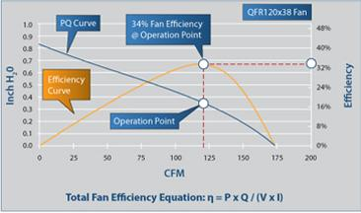

Pick: 2 fans to arrive at nominal power efficiencies of the design RPM (16k vs 32.5k RPM):

Fan 1 (high speed): https://www.delta-fan.com/pfb0412en-e.html
Fan 2 (lower speed): https://www.delta-fan.com/pfb0412ehn-tp06.html

Using this tool, we extract two PQ curves, one from each fan datasheet
https://plotdigitizer.com/app

Next, we use the datasheet to determine the max and min voltages/currents, interpolate these ranges to identify the various operating powers which correspond to the CFM and P values from the curve. We then estimate P_total at any given CFM point.

Then we take the extracted PQ curve, estimate the P_cool for each CFM, and construct an efficiency curve for both fans. These are shown below:

 | 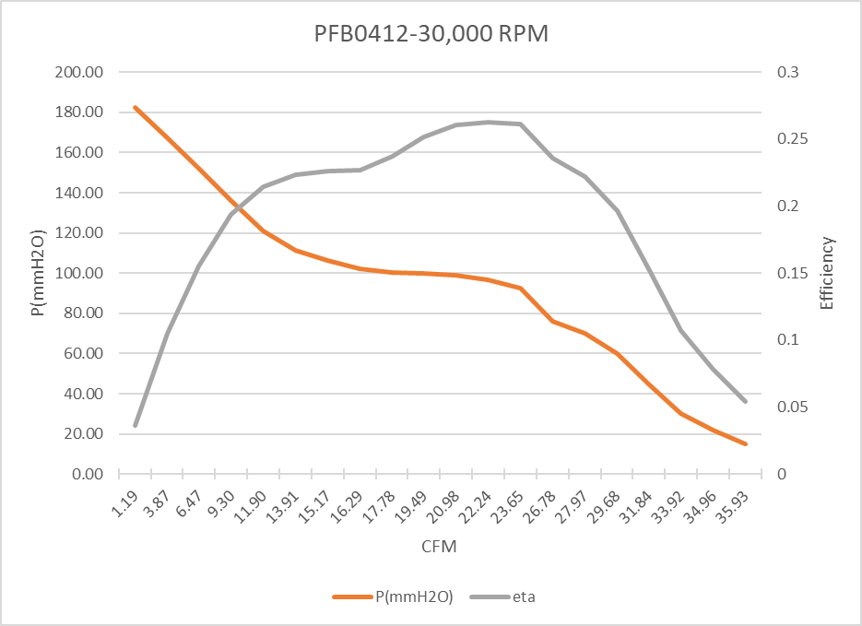 | 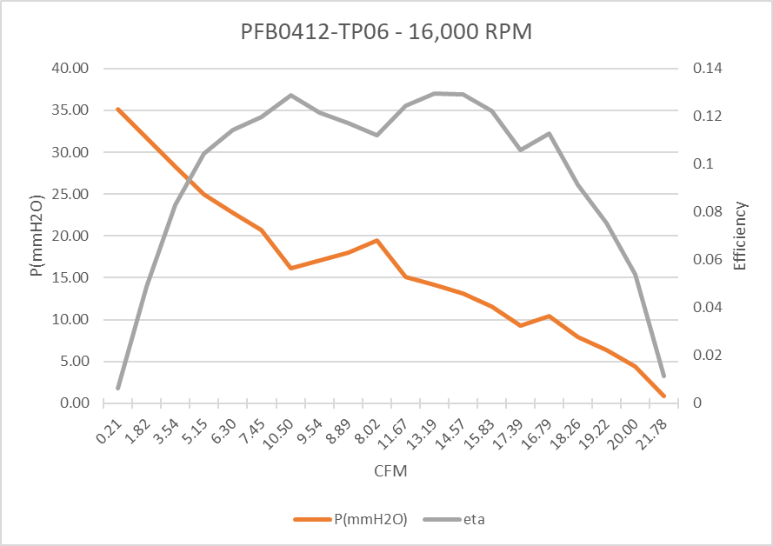
Model | PFB0412 | PFB0412-tp06
RPM | 32500 | 16000
Q(CFM) | 22.24 | 11.67
P(mmH2O) | 96.57 | 15.14
V | 12.20 | 12.01
I | 3.10 | 0.55
P_cool | 9.940125 | 0.817333194
P_tot | 37.82 | 6.564217911
eta | 0.262827 | 0.124513416
V_max | 13.2 | 13.2
V_min | 10.8 | 10.8
I_max | 3.5 | 0.6
I_min | 2.6 | 0.5

Using the above table,

Now, we go to the CFD simulation to help us estimate the h_eff curve. Ideally, we’d sweep over all CFMs for a given fan, but this is unrealistic because any real fan chosen for a server would be chosen based on the optimal

Nominal efficiency (12.4%), 16000 RPM: hotspot temp is 34C, ambient is 19.85


Nominal efficiency (26.2%), 32500 RPM: hotspot temp is xxC, ambient is 19.85:

NOTES:

https://hvacknowitall.com/blog/the-3-fan-laws-and-fan-curve-charts

Fan Law 1: CFM is directly proportional to RPM.

Fan Law 2: Total Static Pressure changes with the square of CFM (or RPM).

Fan Law 3: Horsepower changes with the cube of CFM (or RPM)

